Consciousness
Step 1 of 1

Question 1 of 18Points: 10
____________ refers to a fear of an object or situation that results in significant distress if the fear is realized.
Denial
Phobia
Repression

Question 2 of 18Points: 10
________________ behaviors are considered conscious behaviors.
Controlled
Autonomic
Automatic

Question 3 of 18Points: 10
Abigail is convinced that the mind and brain are one in the same because she believes that the activity within the brain gives rise to the mind. Abigail’s perspective is known as _____________.
dualism
monism
implicit
explicit

Question 4 of 18Points: 10
A sleep cycle takes roughly __________ to complete.
1 hour
2 hours
1.5 hours

Question 5 of 18Points: 10
Ambient light serves as a powerful cue in regulating the secretion of melatonin from the __________.
thyroid
pituitary
adrenal
pineal

Question 6 of 18Points: 10
The ________________ theory of dreaming suggests that dreaming is an important part of moving information into our long term memory.
memory consolidation
activation-synthesis
wish fulfillment

Question 7 of 18Points: 10
________________ is a sleep disorder most commonly experienced by children that involves intense panic.
Insomnia
Sleep apnea
Sleep terrors

Question 8 of 18Points: 10
A sleep deficit of 30 minutes or less can have substantial impacts on mood and performance.
True
False

Question 9 of 18Points: 10
Use of ____________ is sometimes associated with a feeling of euphoria and decreased experience of pain.
depressants
opioids
hallucinogens
stimulants

Question 10 of 18Points: 10
___________ , a stimulant, is the primary psychoactive component of tobacco.
Caffeine
Cocaine
LSD
Nicotine

Question 11 of 18Points: 10
At significantly high doses, ______________ can result in total anesthesia.
LSD
cocaine
barbiturates
amphetamine

Question 12 of 18Points: 10
Codeine is an example of a relatively mild ______________ drug.
opioid
stimulant
hallucinogen
depressant

Question 13 of 18Points: 10
_________________ is a naturally occurring hallucinogenic compound found in a number of mushrooms.
LSD
Benzodiazepines
Psilocybin

Question 14 of 18Points: 10
_________________ refers to craving and using a drug despite the physical, social, financial, and legal costs incurred.
Addiction
Withdrawal
Dependence
Tolerance

Question 15 of 18Points: 10
_________________ is probably the most commonly used stimulant in the world. Use of this drug enhances mood and energy.
Caffeine
Amphetamine
Cocaine

Question 16 of 18Points: 10
___________ are easily accessible depressant drugs because they can be found in a variety of products around the home.
Barbiturates
Inhalants
Benzodiazepines

Question 17 of 18Points: 10
Use of drugs like ________ can create constipation.
cocaine
heroin
amphetamine
caffeine

Question 18 of 18Points: 10
________ is typically taken orally in the form of a sugar cube or a small piece of paper.
Nicotine
Marijuana
LSD

Memory test
Step 1 of 1

Question 1 of 19Points: 10
Which of the following is an example of an explicit memory?
Recalling what you wore on your first date with your spouse
Knowing how to drive from your home to the grocery store
Seeing an ad for a fast food restaurant, which makes you go there to get a burger
Knowing how to ride a bike, even though you haven’t ridden one in years

Question 2 of 19Points: 10
Which of the following is NOT a type of implicit memory?
Semantic memory
Learning through classical conditioning
Priming
Procedural memory

Question 3 of 19Points: 10
"Fill in the blank" question: select the correct answer.
Your psychology professor tells you that your final exam will be a 200 item multiple choice test. Your final exam is an example of a -Select- test.

Question 4 of 19Points: 10
"Fill in the blank" question: select the correct answer.
Kokila can recall a visual image she has previously seen as accurately as if she were looking at it. This phenomenon is known as -Select- memory.

Question 5 of 19Points: 10
What is the storage capacity of short-term memory?
3-4 bits of information
Limitless
5-9 bits of information

Question 6 of 19Points: 10
"Fill in the blank" question: select the correct answer.
Amanda is 48, but she can recall the details of a beach trip that she took with her family when she was 4 years old. This is an example of -Select- memory.

Question 7 of 19Points: 10
"Fill in the blank" question: select the correct answer.
We process new information in ways that make it more relevant or meaningful, which in turn produces stronger memories for the material. This is known as -Select- .

Question 8 of 19Points: 10
"Fill in the blank" question: select the correct answer.
Our memory for information drops off rapidly at first but then levels off after time. This is known as -Select- .

Question 9 of 19Points: 10
Which of the following is the correct psychological definition of retrieval?
The process of reactivating information that has been stored in memory
An increase in retrieval when the external situation in which information is learned matches the situation in which it is remembered
A form of retrieval failure in which we are certain that we know something that we are trying to recall but cannot quite come up with it
Superior retrieval of memories is when the individual is in the same physiological or psychological state as during encoding

Question 10 of 19Points: 10
Why are schemas important for long-term memory?
Schemas are important because they help us remember new information by providing an organizational structure for it.
Schemas are important because they facilitate spreading activation of memory cues.
Schemas are important because they help us retrieve information faster.

Question 11 of 19Points: 10
Which of the following is a true statement regarding context-dependent learning?
We can continue to learn even after we think we know the information perfectly.
Information is learned better when it is studied in shorter periods spaced over time.
We have better retrieval when we are in the same psychological state as we were when we learned the material.
We have better retrieval when it occurs in the same situation in which we learned the material.

Question 12 of 19Points: 10
"Fill in the blank" question: select the correct answer.
Fill in the blank-Select- refers to the strengthening of the synaptic connections between neurons as result of frequent stimulation.

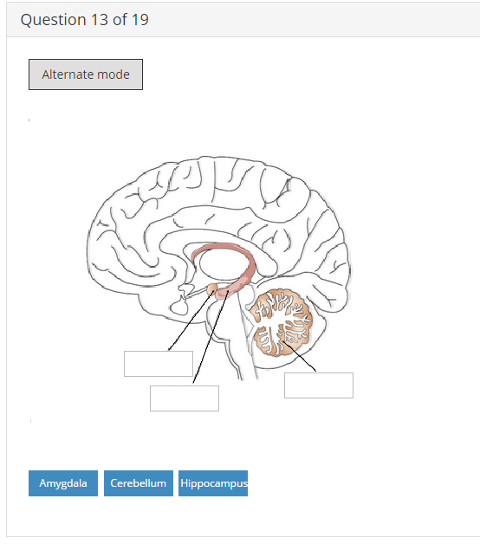

Question 14 of 19Points: 60
Source monitoring
Heuristics
Overconfidence
Algorithms
The misinformation effect
Counterfactual thinking
Example | Term
Layla has been married to Jovani for 6 years. She wonders what her life would be like if she had married her high school sweetheart, Kevin, instead.
After seeing several television news reports about home break-ins, you make a judgment that breaks-ins are much more common in your area than they really are. Now you make sure to keep your doors and windows locked at all times.
You were at a basketball game last night. You witnessed an argument between two players on opposing teams in which a few foul words were exchanged. The next day, the newspaper reported that a fist fight occurred between at least 8 basketball players. Now you remember the event as a huge brawl between both teams.
You wake up this morning and recall that Dr. Denton said he was giving a biology test today. You don’t confuse this with the English test Dr. Washington said she is giving on Friday.
Stephen uses a mathematical formula to determine how many square feet of tile he needs to purchase for his kitchen remodeling project.
After the New England Patriots won the Super Bowl, Rupert bragged to his friends that he predicted their win all along.

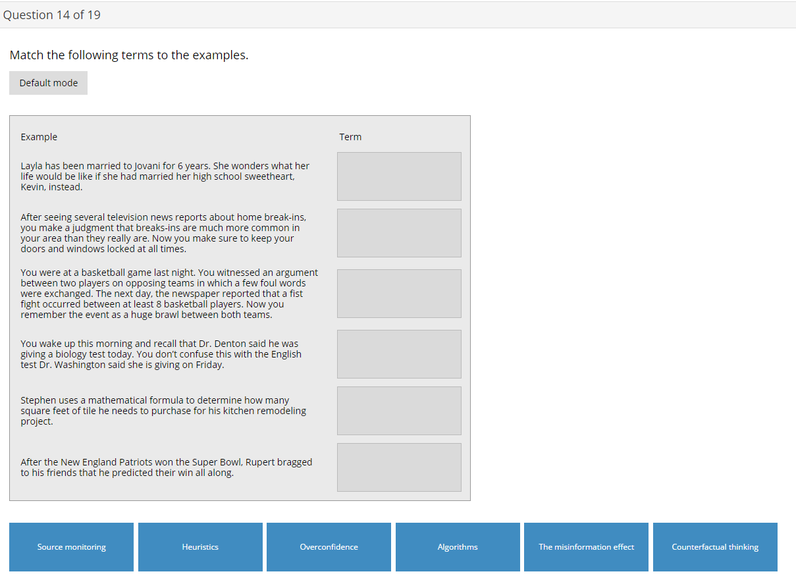

Question 15 of 19Points: 10
A researcher gave participants a candle, a box of thumbtacks, and a book of matches, and asked them to attach the candle to the wall so that it did not drip onto the table below. Few of the participants realized that the box could be tacked to the wall and used as a platform to hold the candle. This is an example of which cognitive bias?
Counterfactual thinking
Confirmation bias
Overconfidence
Functional fixedness

Question 16 of 19Points: 10
"Fill in the blank" question: select the correct answer.
If we think that a person is an extrovert, we might ask her about ways that she likes to have fun, thereby making it more likely that we will confirm our beliefs. The tendency to verify and confirm our existing memories rather than to challenge and disconfirm them is known as -Select-.

Question 17 of 19Points: 10
What are schemas?
Schemas are mental representations of the world that are formed and adjusted using the processes of assimilation and accommodation as a person experiences life.
Schemas are recipe-style information-processing strategies that guarantee a correct answer at all times.
Schemas are information-processing strategies that are useful in many cases but may lead to errors when misapplied.

Question 18 of 19Points: 10
"Fill in the blank" question: select the correct answer.
People who see a flipped coin come up heads five times in a row will frequently predict, and perhaps even wager money, that tails will be next. This behavior is known as the-Select-.

Question 19 of 19Points: 10
The degree to which a particular social object stands out relative to other social objects in a situation is known as which of the following?
Cognitive accessibility
Overconfidence
The gambler’s fallacy
Salience

Sensing & Perceiving
Step 1 of 1

Question 1 of 38Points: 10
"Fill in the blank" question: select the correct answer.A researcher conducts studies to try to determine the absolute threshold of a given sensory modality. The branch of psychology that would be most relevant to this research would be-Select-.

Question 2 of 38Points: 10
"Fill in the blank" question: select the correct answer.-Select- occurs when molecules in the air interact with olfactory receptors causing them to send action potentials to the part of the brain that processes olfactory information.

Question 3 of 38Points: 10
"Fill in the blank" question: select the correct answer.Understanding that the high pitch noise that you hear is your kitchen timer alerting you to the fact that your dinner is done is an example of -Select-.

Question 4 of 38Points: 10
"Fill in the blank" question: select the correct answer.Placing a salty solution on the surface of the tongue would cause taste buds to begin to produce neural impulses. This process is referred to as -Select-.

Question 5 of 38Points: 10
"Fill in the blank" question: select the correct answer.When transduction occurs, mechanoreceptors of the skin convert physical pressure into -Select-.

Question 6 of 38Points: 10
"Fill in the blank" question: select the correct answer.When -Select- are brushed by the gelatinous mass in the semicircular canals of the inner ear, transduction occurs.

Question 7 of 38Points: 10
"Fill in the blank" question: select the correct answer.Exposing photoreceptors to light results in neural impulses being sent to the parts of the brain that process visual information. This is known as -Select-.

Question 8 of 38Points: 10
"Fill in the blank" question: select the correct answer.Movement in the hair cells of the inner ear causes -Select- to be sent to the parts of the brain that process auditory information.

Question 9 of 38Points: 10
"Fill in the blank" question: select the correct answer.A person may refuse to pay an extra dollar for a can of soda, but they act as if there is no difference in two big screen TVs whose prices differ by a dollar. This example demonstrates how the-Select- is a proportion of stimulus intensity, rather than an absolute change between stimuli.

Question 10 of 38Points: 10
"Fill in the blank" question: select the correct answer.Signal detection analysis involves differentiating between true -Select- and background noise.

Question 11 of 38Points: 10
"Fill in the blank" question: select the correct answer.The human eye is sensitive to a very limited range of -Select- of electromagnetic energy.

Question 12 of 38Points: 10
"Fill in the blank" question: select the correct answer.-Select- occurs when problems in accommodation of the lens result in images being focused before reaching the retina.

Question 13 of 38Points: 10
"Fill in the blank" question: select the correct answer.The visual areas of the -Select- receive information directly from the optic nerve. From here, the information is sent to the visual cortex.

Question 14 of 38Points: 10
"Fill in the blank" question: select the correct answer.There are no rods and cones in the -Select-.

Question 15 of 38Points: 10
________________ are to Young-Hemholtz theory as ______________ are to opponent process theory.
Rods; visual cortexes
Cones; rods
Cones; visual cortexes

Question 16 of 38Points: 10
"Fill in the blank" question: select the correct answer.The classic vase-face image illustrates the Gestalt principle of -Select-.

Question 17 of 38Points: 10
"Fill in the blank" question: select the correct answer.When looking at a drawing you are more likely to see two lines that smoothly cross one another rather than four line segments that angle sharply to a single central point. This illustrates the Gestalt principle of -Select-.

Question 18 of 38Points: 10
"Fill in the blank" question: select the correct answer.-Select- is a monocular depth cue in which parallel lines appear to converge at a distance.

Question 19 of 38Points: 10
"Fill in the blank" question: select the correct answer.The -Select- occurs when apparent motion is perceived as a result of turning on and off a series of lights.

Question 20 of 38Points: 10
"Fill in the blank" question: select the correct answer.The stimulus for the auditory system is -Select-.

Question 21 of 38Points: 10
"Fill in the blank" question: select the correct answer.The observation that high pitched sounds peak near the opening of the cochlea while lower pitched sounds peak near the opposite end supports the -Select-.

Question 22 of 38Points: 10
"Fill in the blank" question: select the correct answer.As we age, we all experience sensorineural hearing loss that often impacts our ability to detect -Select- pitched sounds first.

Question 23 of 38Points: 10
"Fill in the blank" question: select the correct answer.The -Select- is the ossicle that comes into direct contact with the oval window.

Question 24 of 38Points: 10
"Fill in the blank" question: select the correct answer.Movement of fluid inside the -Select- ultimately leads to sound waves being converted into neural impulses.

Question 25 of 38Points: 10
"Fill in the blank" question: select the correct answer.Once taste related or smell related chemicals have been converted into neural impulses, they are transmitted to -Select- regions of the brain for further processing.

Question 26 of 38Points: 10
"Fill in the blank" question: select the correct answer.Repeated stimulation of pain receptors will lead to an experience of -Select-.

Question 27 of 38Points: 10
"Fill in the blank" question: select the correct answer.-Select- is to the vestibular system as the cochlea is to the auditory system.

Question 28 of 38Points: 10
After running a marathon, some people report that they feel a sense of euphoria. Which neurotransmitter would be involved in this experience?
glutamate
endorphin
GABA

Question 29 of 38Points: 10
"Fill in the blank" question: select the correct answer.While watching television, the audio and video feed become mismatched, and this creates the perception that the actors are saying something else altogether. This would be an illustration of the-Select-.

Question 30 of 38Points: 10
"Fill in the blank" question: select the correct answer.Some users of hallucinogenic drugs report experiences of -Select- when they see flashes of light when they hear music.

Question 31 of 38Points: 10
"Fill in the blank" question: select the correct answer.While you watch a team in white pass a basketball, you fail to notice a gorilla strolling through the basketball court. This illustrates the power of -Select-.

Question 32 of 38Points: 10
"Fill in the blank" question: select the correct answer.While taking notes on your professor’s lecture, you suddenly become aware of the fact that your friend in class is whispering your name. This example illustrates the -Select-.

Question 33 of 38Points: 10
"Fill in the blank" question: select the correct answer.As you move around your den, the image that your couch casts on your retina changes dramatically. However, your perception of the couch doesn’t change. This illustrates the concept of -Select-.

Question 34 of 38Points: 10
"Fill in the blank" question: select the correct answer.Our ability to perceive an object as maintaining its size despite the fact that the size of the images of the object on our retina is changing as we move closer or farther from the object is known as-Select-.

Question 35 of 38Points: 10
"Fill in the blank" question: select the correct answer.In the Mueller-Lynn illusion, the line with arrow shapes capping it is perceived to be -Select- us and therefore smaller in size than the line segment capped with v shapes.

Question 36 of 38Points: 10
"Fill in the blank" question: select the correct answer.In the -Select- illusion the circle that is surrounded by small circles appears larger than the circle surrounded by the large circles.

Question 37 of 38Points: 10
"Fill in the blank" question: select the correct answer.The Hering and Wundt illusions work because the background lines provide -Select- cues.

Question 38 of 38Points: 10
"Fill in the blank" question: select the correct answer.The Ponzo illusion relies on a sense of depth that is created by two parallel lines that appear to converge in the distance. This sense of depth is accomplished through the use of the monocular depth cue known as -Select-.

Learning
Step 1 of 1

Question 1 of 13Points: 10
In Pavlov's classical conditioning experiments, the bell was the _____ to be paired with the ________.
US; salivation
US; sight of food
CS; sight of food
CR; US

Question 2 of 13Points: 10
Your dog Bubby has learned that every time you tell him to sit he gets a treat. Eventually you stop giving him treats when he performs this trick. After a few days, you stop doing this, and he no longer sits on command. One day at the park, he hears a dog owner say “Sit” to her dog, and Bubby sits also. This is an example of ________.
Spontaneous recovery
Extinction
generalization

Question 3 of 13Points: 10
John B. Watson conditioned Little Albert to be afraid of a white rat. Little Albert also became afraid of other white things, such as a white bunny and a Santa Claus beard. What kind of new conditioning could help him stop fearing all those other white things?
Discrimination
Extinction
Generalization

Question 4 of 13Points: 10
"Fill in the blank" question: select the correct answer.Little Bella has to take some yucky medicine. When she sees her mother pull down the bottle from the shelf, Bella hides under her bed so her mother has started to put on Bellas favorite video to keep the child from hiding. But now, when Bella sees her mother turn on the video, she hides under the bed. This is an example of .

Question 5 of 13Points: 10
When Roberto was in the military, he was injured in a training exercise involving a climbing wall. Now he won’t go up on even small ladders. This is how classical conditioning can lead to ____________.
second order conditioning
discrimination
a phobia
extinction

Question 6 of 13Points: 10
From an evolutionary perspective, which of the following is most likely to be a target stimuli for a phobia? Choose all that apply.
social situations
heights
driving
snakes

Question 7 of 13Points: 20
"Fill in the blank" question: select the correct answer.In you learn a new behavior by noticing the consequences of that behavior. This differs from , in which you learn a new cue for an existing behavior by associating the new cue with the existing cue.

Question 8 of 13Points: 10
You are playing Monopoly with friends. You land in jail. You want to roll a double to get out so you can save money. You know the odds of rolling a double on a single throw of the dice, but you keep trying. This is an example of a __________ schedule.
variable interval
fixed interval
fixed ratio
variable ratio

Question 9 of 13Points: 10
B. F. Skinner trained pigeons to do many things, including pecking a bar and turning in a circle. Imagine that you want to train a pigeon to peck a bar. First, you reward your pigeon with a food pellet every time he goes near the bar. Eventually, you only reward your pigeon if his beak touches the bar. Finally, you only reward your pigeon when he pecks the bar. You are using a technique known as __________.
classical conditioning
priming
shaping

Question 10 of 13Points: 20
"Fill in the blank" question: select the correct answer.Ron is trying to solve a problem. Rather than try various methods, he had a sudden understanding of a solution to the problem, This is an example of . Carrie is trying to solve a problem. She has tried several methods and finally found a solution. This is an example of .

Question 11 of 13Points: 10
Katrina's father drives her home from dance class each week. One day, he blacks out at the wheel. She jumps out, pushes him over, and drives the rest of the way home. By then, he has recovered. This is an example of ________.
observational learning
insight learning
trial and error learning
latent learning

Question 12 of 13Points: 10
Samuel grows up in a home where he watches his father abuse his mother and get away with it. When Samuel is an adult, he gets married. When he becomes angry, he hits his wife, just like his father did. This is an example of _______.
shaping
generalization
observational learning
positive reinforcement

Question 13 of 13Points: 10
Marcus plays violent video games. In his favorite game, the characters use martial arts skills to defeat their opponents. One evening, Marcus gets angry at his little sister, Britney. Based on Bandura's theory of observational learning, which of the following is Marcus most likely to do?
Marcus will walk away. Viewing violence has no effect on behavior.
Marcus will deliver a karate kick to his sister's stomach because viewing violence can increase levels of aggression.
Marcus will talk calmly to his sister and tell her why he feels angry because viewing violence will make him more sensitive to his actions.

Language
Step 1 of 1

Question 1 of 10Points: 10
________________, or the sounds of a given language, are produced by movements in our lips, teeth, tongues, throat, and vocal chords.
Morphemes
Syntax
Phonemes

Question 2 of 10Points: 10
____________ are combined into ___________ to convey meaning in a given language.
Phonemes; morphemes
Morphemes; phonemes

Question 3 of 10Points: 10
Mastering ____________ of a given language involves learning that language’s rules for constructing sentences.
Syntax
Morphemes
Phonemes

Question 4 of 10Points: 10
The ____________ in which language occurs provides important contextual information that helps us interpret meaning.
Phoneme
Syntax
Situation

Question 5 of 10Points: 10
After suffering damage to ___________, a person may exhibit fluent aphasia, which refers to a condition in which a person has no problem producing speech, but their speech is nonsensical.
Wernicke’s area
Broca’s area
Occipital lobe

Question 6 of 10Points: 10
By the time children are 2 years old, they generally have a vocabulary of several thousand words.
True
False

Question 7 of 10Points: 10
Nature is to _____________ as nurture is to ______________.
Skinner; Chomsky
Chomsky; Skinner

Question 8 of 10Points: 10
Speaking two languages is associated with ______________ cognitive function when compared to the cognitive abilities of people who speak only one language.
Enhanced
Slower
No differences

Question 9 of 10Points: 10
The bonobo, Kanzi, demonstrated an ability to learn signs faster when he was younger. This would be consistent with which idea related to language acquisition?
Syntax
Sensitive period
Morphemes

Question 10 of 10Points: 10
Which of the following characteristics probably makes language most distinct from other forms of communication?
Phonemes
Morphemes
Generativity

Intelligence
Step 1 of 1

Question 1 of 16Points: 10
As we grow older, our accumulated knowledge of the world increases. In other words as we age, our ___________ intelligence increases.
crystallized
specific intelligence
fluid

Question 2 of 16Points: 10
An IQ score is equal to ____________ divided by ________________ and multiplied by 100.
chronological age; mental age
mental age; chronological age

Question 3 of 16Points: 10
The _____________ is an adult intelligence scale that yields scores on four domains, including verbal, perceptual, working memory, and processing speed.
WPPSI-III
WAIS-IV
Stanford-Binet

Question 4 of 16Points: 10
In general, as a score moves further away from the mean, there will be ___________ number of frequencies of observation for that score.
fewer
a greater
no change in

Question 5 of 16Points: 10
Approximately 68% of all scores will fall within one _________________ of the average intelligence score.
standard deviation
distribution
frequency

Question 6 of 16Points: 10
Gardner would argue that a professional dancer likely had high levels of ________________ intelligence.
kinesthetic
musical
naturalistic
spatial

Question 7 of 16Points: 10
People who are more creative tend to work on projects that have _____________ for them.
no risks involved
practical implications
earning potential
intrinsic interest

Question 8 of 16Points: 10
Gardner’s idea of ________________ reflects the concept of emotional intelligence.
interpersonal intelligence
linguistic intelligence
kinesthetic intelligence

Question 9 of 16Points: 10
_________________ is the part of emotional intelligence that is most related to cognitive intelligence.
Emotion recognition
Emotion assessment
Emotion regulation

Question 10 of 16Points: 10
Those who espouse an entity theory of intelligence tend to _____________ academic challenges.
avoid
manufacture
seek out

Question 11 of 16Points: 10
Someone who accepts an entity theory of intelligence would expect the intelligence scores of young children to _______________ as they age.
increase
decrease
stay the same

Question 12 of 16Points: 10
A student who responds to a failing grade with a renewed commitment to studying her notes indicates that she holds a(n) _____________ theory of intelligence.
incremental
entity
triarchic

Question 13 of 16Points: 10
According to Flynn’s research, poor, less modernized countries experience a three point decrease in the average IQ every decade. TRUE or FALSE?
True
False

Question 14 of 16Points: 10
Women may be less likely to fall on the extreme low end of IQ score distributions because _________ plays a protective role against biological factors that affect intellectual functioning.
testosterone
estrogen
Y chromosome

Question 15 of 16Points: 10
After conducting an extensive review of IQ research, the APA task force concluded that racial and ethnic differences in IQ are _________________________.
due to genetic differences and relatively unchangeable
due to biased tests and testing procedures
not well explained

Question 16 of 16Points: 10
Stereotype threat can affect individuals with advantaged social status as well as individuals with a minority status. TRUE or FALSE?
True
False

